**Software Requirements Specification**

**For**

**E-Commerce Website**

[Date]

Ankit Jaisawal

AmaZON

**ABSTRACT**

Online shopping website is online market place where retailer are connected. The objective behind this project to make interactive so that user can see the product at one place and easily they can purchase. It would make searching, viewing and selection of a product easier. It contains a sophisticated search engine for users to search for products specific to their needs. Customer always wants to visit large market place customer never wants to go at the store which is alone out of the market.

Customer are the core of all business strategies. Therefore, ensuring the great customer experience is of prime importance for the growth of the business. You need to meet your customers where they spend their time. More than 60% of consumers look for purchasing goods and services online.

**Table of Content**

1. Introduction……………………………………………………………………………………………..
   1. Overview………………………………………………………………………………………
   2. Goal………………………………………………………………………………………………
   3. Need of the application…………………………………………………………………
   4. Scope……………………………………………………………………………………………

1.5 Platform Specification-Deployment……………………………………………..

* + 1. Hardware Specification………………………………………………………

1.5.2 Software Specification…………………………………………………………

2. Swot Analysis…………………………………………………………………………………………..

3. System Requirement Analysis…………………………………………………………………..

3.1Information Gathering………………………………………………………………………

3.2System Feasibility……………………………………………………………………………..

3.2.1 Economic Feasibility…………………………………………………………………..

3.2.2 Technical Feasibility……………………………………………………………………

3.2.3 Operational Feasibility………………………………………………………………..

4. How to sell on amazon………………………………………………………………………………

4.1 Register a new Amazon sellers account……………………………………………

4.2 Enter your complete accurate details……………………………………………….

4.3 Select your sustainable plan……………………………………………………………..

4.4 Verify with your phone number………………………………………………………..

5. System Analysis…………………………………………………………………………………………

5.1 ER Diagram………………………………………………………………………………………

5.2 Use case Diagram…………………………………………………………………………….

5.3 Class Diagram…………………………………………………………………………………..

5.4 Object Diagram………………………………………………………………………………..

5.5 Package Diagram…………………………………………………………………………….

5.6 Deployment Diagram……………………………………………………………………….

6. Design………………………………………………………………………………………………………..

6.1 Design Goals……………………………………………………………………………………..

6.2 Procedural/Modular Approach..……………………………………………………….

6.2.1 User Module…………………………………………………………………………….

6.2.2 Listing Manager Module…………………………………………………………..

6.2.3 Shop Products Module……………………………………………………………..

6.2.4 Product Description Module…………………………………………………….

6.2.5 Cart Details Module………………………………………………………………….

7. Implementation…………………………………………………………………………………………

8. Testing………………………………………………………………………………………………………

8.1 Unit Testing……………………………………………………………………………………..

8.2 Integration Testing…………………………………………………………………………..

8.3 Validation Testing…………………………………………………………………………….

8.4 White Box Testing……………………………………………………………………………

8.5 Black Box Testing…………………………………………………………………………….

9. Finings, Suggestions and Conclusion………………………………………………………..

9.1 Findings………………………………………………………………………………………….

9.2 Conclusion……………………………………………………………………………………..

1. **Introduction**
   1. **Overview**



Amazon is the largest internet based company in the United States. Amazon started as an online bookstore. But soon diversified, selling DVDs, vhss, cds, video and mp3 downloads/streaming, software, video games, electronics, apparel, furniture, food, toys, and jewelry. The company also produces consumer electronics notably, kindle, fire tablets, fire tv and phone and is a major provider of cloud computing services.

Amazon has separate retail websites for united states, united kingdom & Ireland, France, Canada, Germany, the Netherlands, Italy, Spain, Australia, brazil, japan, china, India and Mexico, with sites for Sri lanka and south east Asian countries coming soon. Amazon also offers international shipping to certain other countries for some of its products. In the year 2011, it had professed an intention to launch its websites in Poland, and Sweden. In early June 2013, Amazon.com had launched their Amazon India marketplace without any marketing campaigns. In July, 2013, Amazon had announced to invest $2 billion (RS 12,000 cores) in India to expand business, after its largest Indian rival Flip kart too had announced to invest$1 billion.

Amazon is e-commerce Company with total annual sales of worldwide revenue US $221.6 billion in 2021. The company amazon was started in July of 1994 and it was originally called CAABRA. First it was an online book store, which at that time was a brand new concept.

The company was located in Washington State. Its founder, current CEO and chairman of the board as well as president is Jeff Bezos.

In 2013, Amazon was entered in India. In July, 2016 Amazon launched its paid service, such as Amazon kindle, Amazon prime, video, Amazon mp3 etc.

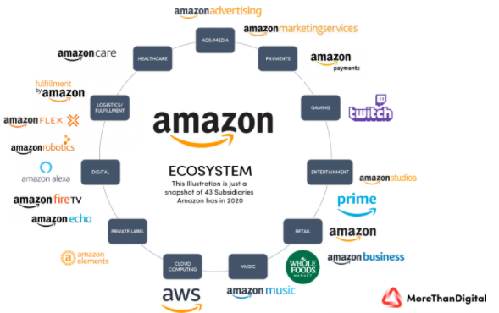

**Fig: Amazon Services**

**1.2 Goal**

Online shopping is the use of electronic communications and digital information processing technology in business transaction to create, transform, and redefine relationships for value creation between or among organization, and between organizations and individuals. The primary goal of an e-commerce site is to sell products online. It provides the user with a catalog of different product available for purchase in the store.

The goal of this application is to develop a web based interface for online retailers. The system would be easy to use and hence make the shopping experience pleasant for the users. The goal of this application is

* To develop an easy use of web based interface where user can search products, view products all the description.
* In order to facilitate online purchase a shopping cart is provided to the user.
* This interface helps user to view complete specification of the product along with various images and view the feedback or earlier customer. They can also write feedback their feedback.
  1. **Need of the application**

In the market there are large number of e-commerce Online Shopping website offering large number of product which meet the shopping interest of large customers.

**Problem:**

* Issue relating to product quality the most common problem faced by customers in online shopping is that there is no guarantee of product quality.
* We also know that when customer looking for purchasing the product he wants to first use the product. But it is not possible in online marketplace.
* Issues with online shopping have been increasing at a rapid rate. E-commerce marketplaces often charges are hidden costs after the product is finalized by the customer. Website hides shipping charges and many more.

**Solution:**

* The motive of this Online Shopping Web Application is to focus on the customer problems like quality of product we would try to give best product in limited costs and monitor feedback of customer and perform action according to them.
* We add interactive graphics which create the illusion to customer that they are using the product and that product belongs to their need.
  1. **Scope**
* E-commerce is huge market place.
* The scope of e-commerce business is increasing undoubtedly.
* Selling can be centered on the global client.
  1. **Platform Specifications – Deployment** 
     1. **Hardware Specification**
* Processor – Dual core or above
* RAM 500 MB
* Minimum Space Required 100 MB
  + 1. **Software Specification**
* Windows Operating System
* NetBeans IDE
* JDK Version 8
* Platform JSP Framework
* Database SQL Server 2012

**2. Swot Analysis**

**Strengths:**

* **Strong background and keep pockets:** Built on its early successes with books, Amazon now has product categories that include electronics, toys, games, home and kitchen, white goods, brown goods and much more. Amazon has evolved as a global ecommerce giant in the last 2 decades.
* **Customer centric:** Company’s robust crm has created customer centric processes in order to carefully record data on customer’s buying behaviour. This enables them to offer individual items, related items or bundle them as an offer, based upon preferences demonstrated through purchases or items visited. Also, the company claims that 55% of their customers are repeat buyers resulting in low cost of acquisition of new buyers.
* **Cost leadership:** In order to differentiate itself, company has created several strategic alliances with other companies to offer superior customer service. The most important strategic tie ups are with logistics provides who control costs. Because of playing on economies of scale, Amazon is able to lower the inventory replenishment time.
* **Efficient delivery network:** With its strategic partners & due to its Amazon fulfilment centers, Amazon has created a deep & structured network in order to make the product available even at remote locations. It also has free of cost delivery charges in certain geographies.
* **Global Strategy:** By using the strategy of “go global & act local”, Amazon is able to fight with domestic e-commerce companies through absorbing & by forming / partnering with supply chain companies. The branding too is done as per local taste. For example- in India, Amazon is currently using the “aur dikhao” campaign to encourage users to browse more of their products.

**Weakness:**

* **Tax avoidance issue:** Amazon has attracted negative publicity on account of tax avoidance in countries like US & UK. Most of its revenue is generated from these well established markets.
* **High debt:** In many developing nations Amazon is still struggling to make the business profitable thereby affecting the overall profitability of the group resulting into high debt.
* **Product flops:** Amazon launched the fire phone in the us which was a big flop. At the same time, kindle fire did not pick up as strongly as kindle did. Thus, there were several product flops which caused a dent in Amazon’s deep pockets.

**Opportunities:**

* **Backward integration:** Amazon can come up with its in-house brands in different product categories. They can also differentiate their offering. This will help them make profits in highly competitive e-commerce market.
* **Global expansion:** Expansion mainly in Asian & developing economies will help Amazon because those are the markets with low competition in e-commerce industries & are not saturated like developed economies.
* **Acquisitions:** By acquiring e-commerce companies it can decrease the competition level & also can use the specialized capacity of the other company.
* **Opening physical stores outside U.S:** By doing this Amazon can help the customers to engage with the brand, resulting in increase in repeat purchases & increase in loyal customer base.

**Threats:**

* **Low entry barriers of the industry:** Low entry barriers affect the current player’s business as more & more company means tough competition, price wars, shrinking margins & losses resulting into questioning the sustainability of the players.
* **Government regulations:** Not having clarity on the issues related to FDI in multi brand retail, has been a big hurdle in the success of the e-commerce players in many developing nations.
* **Local competition:** India has Snapdeal and Flipkart who are local e commerce retailers and are taking away majority of the market. Similarly, there are many local players who take bites from the market share thereby making it hard for a big player like Amazon to make profits.

**3. System Requirement Analysis**

**3.1 Information Gathering**

As we have discussed the goal of application is ease of use and to provide an interactive interface. The working of application is made convenient and easy to use. The working performance can be measured and improved with help customer feedback. We regularly keep eyes on the customer feedback.

As E-commerce is a digital sales pitch where different types of products are available at the one place with complete specification of the product with figure. Customer can zoom the product. The customer who knows their requirement they can easily search the product by the product name with the help of available option just by clicking the button. The customer who have to figure out the product they can filter the product from the available list of product with the help of different options. The customer can add the product to cart it is same like bucket where user can add product to cart by clicking add to cart button and also remove the product from the cart by clicking the remove button.

**3.2 System Feasibility**

The system feasibility can be divided into the following sections.

**3.2.1 Economic Feasibility**

The project is economically feasible because it saves lots of time. The only cost is involved and having a computer with minimum requirement. While accessing the application, the only internet cost is involved. Customer can use the application from anywhere with the help of computer or mobile with a good internet connectivity.

**3.2.2 Technical Feasibility**

To deploy the application, the only technical aspects needed are mentioned below:

* Operating System Windows 7/8/10
* IDE
* JSP(Java server pages)
* Database SQL Server 2012

For users:

* Internet Browser
* Internet Connection

**3.2.3 Operational Feasibility**

Our project is user friendly. So the user who does not have any technical background can operate this application. In application Icons menus and its options describing its meaning itself. So the application is easy to operate.

**4. How to sell on amazon**

**4.1 Register a new Amazon seller’s account**

If you want to sale anything on the site first thing you will need is Amazon seller account. For that you have to create user name and password.

**4.2 Enter your complete accurate details**

Add seller’s information detailing your desired display name, appropriate address and other applicable information necessary for a valid transaction.

**4.3 Select your sustainable plan**

Then decide whether you want to be professional or individual sellers

* The individual plan is the best for those who only want to sell few items (this plan is entirely free).
* The professional plan is for those who want to sell in the bulk (this plan runs a monthly subscription fee 40$).

**4.4 Verify with your phone number**

Verify said information first, you have to enter your name and phone number and click the call me now button. You will receive a call from Amazon and promoted, enter the pin number appearing on your screen on your phone prior to hanging up. You will see a verification message indicating that you are ready to beginning to sell on Amazon.

**5. System Analysis**

After carefully analysing the requirements and functionality of the web application, I had two important diagrams by the end of the analysis phase. They are the ER diagram and data flow diagram which were the basis for finding out entities and relationships between them, the flow of information.

**5.1 ER Diagram**

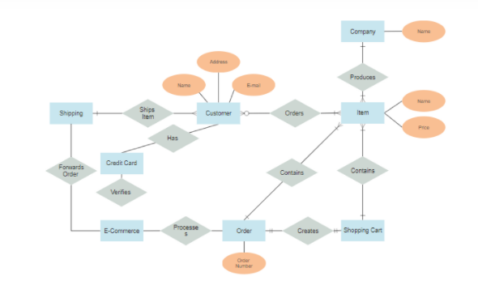

**Fig: ER Diagram**

**5.2 Use Case Diagram**

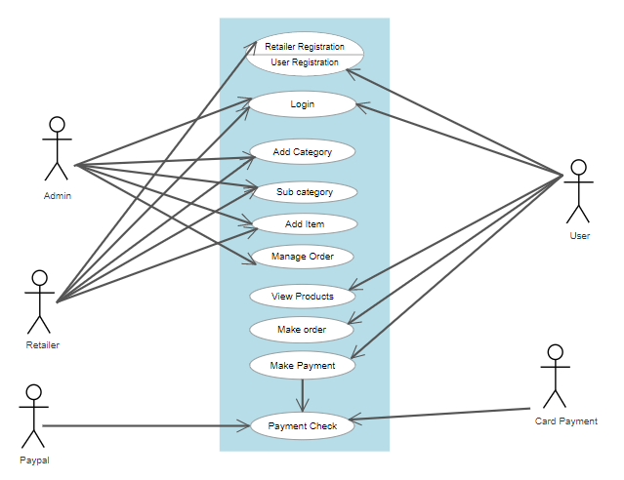

**Fig: Use case diagram of E-Commerce**

**5.3 Class Diagram**

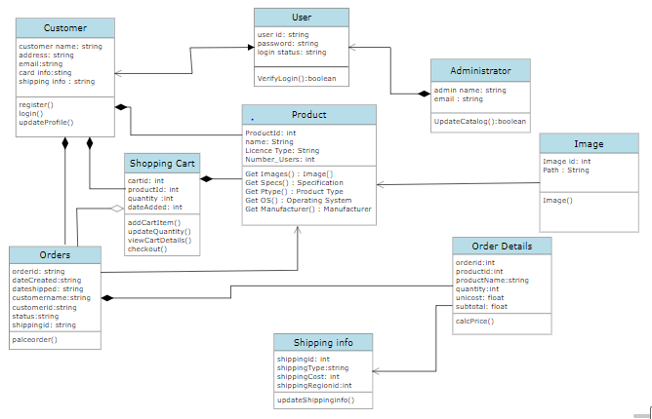

**Fig: Class Diagram of E-Commerce**

**5.4 Object Diagram**

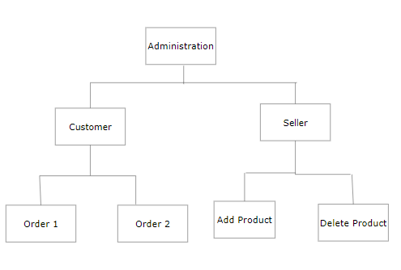

**Fig: Object Diagram**

**5.5 Package Diagram**

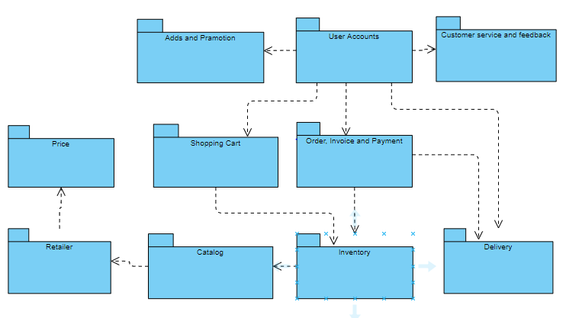

**Fig: Package Diagram of E-Commerce**

**5.6 Deployment Diagram**

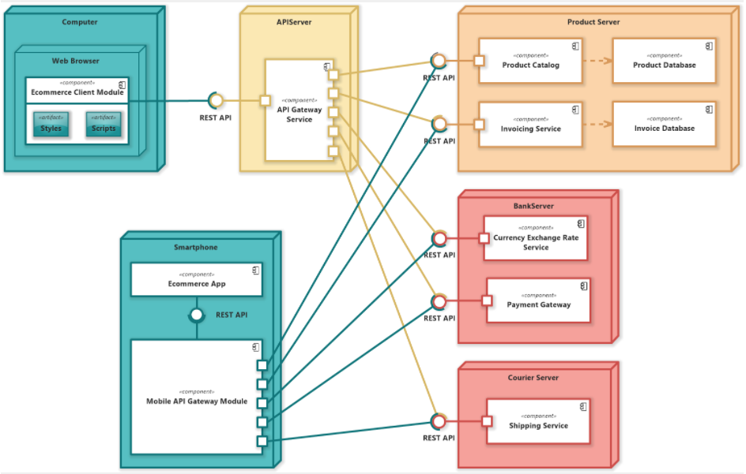

**Fig: Deployment Diagram of E-Commerce**

**6. Design**

**6.1 Design Goals**

* The design of application user friendly user can easily understand with the help icon. Because icon define the work itself.
* In design we have forms registration, login, list of product form, search option, display, cart, filter option.
* We have product list form where user can view the list of products and user can search any product from the current page.
* In design of interactive application user can filter the product based on their needs.
* Design has feature like shopping card, point, zoom.

**6.2 Procedural/Modular Approach**

Following are all the modules designed for the online shopping system. Some of the procedural approaches are

**6.2.1 User Module**

In this application the customer can search the product but they cannot place the order without login, so first do the registration and do login user can also update their profile all the details of the user stored in database.

**6.2.2 Listing Manager Module**

Listing manager list all the products on the application listing manger includes product image all the description of the product.

**6.2.3 Shop Products Module**

This module starts when user visit the home page or when user searches for a product by entering a search bar.The product search by the user if is available then product is displayed with types of product belong to the same type. User can also filter these product based on the parameters like product type, price limit of product, manufacturer etc.

**6.2.4 Product Description Module**

This module starts when user visit the description page user can see the all description like manufacturer, features, warranty, and price on bank with several images. User can also view the exchange policy of the product and discount of the product like what discount applicable on the product.

**6.2.5 Shopping Cart Module**

This module works when user view the shopping cart. The total price of all the products added to cart is displayed. A user can edit the quantity of each product or remove the product from the shopping cart. A user can remove the product from the cart by clicking a button or by dragging the product and dropping it outside the cart. The total price changes accordingly when a user edits the quantity of a product or when a product is removed from the cart.

**7. Implementation**

The software implementation stage involves the transformation of the software technical data package into one or more fabricated, integrated, and tested software configuration items that are ready for software acceptance testing.

**8. Testing**

Testing is perform for validation and verification of the software does what it is supposed to do.

There are many different types of testing.

**8.1 Unit Testing**

Unit testing is a software testing technique by means of which individual units of software i.e. group of computer program modules, usage procedures and operating procedures are tested to determine whether they are suitable for use or not. Some of the usage of unit testing are

* It is a testing method using which every independent modules are tested to determine if there are any issue by the developer himself.
* It is correlated with functional correctness of the independent modules.

**8.2 Integration Testing**

It focuses on the construction and design of the software. You need to see that the integrated units are working without errors or not.

Integration testing is performed in the next phase of testing. Here they test individual components of the system and then test them as a collective group. This allows software testers to determine the performance of individual component as a group and identify any problems in the interface between the modules and functions.

**8.3 Validation Testing**

The process of evaluating software during the development process or at the end of the development process to determine whether it satisfies specified business requirements.

Validation Testing ensures that the product actually meets the client's needs. It can also be defined as to demonstrate that the product fulfils its intended use when deployed on appropriate environment.

It answers to the question, Are we building the right product?

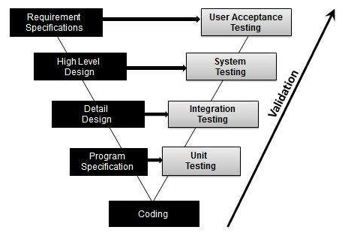

**Fig: Workflow of validation testing**

**8.4 White box testing**

White box testing is software testing technique in which internal structure, design and coding of software are tested to verify flow of input-output and to improve design, usability and security. In this testing code is visible to testers so it is also called clear box testing.

**8.5 Black box testing**

Black box testing is a technique of software testing which examines the functionality of software without peering into its internal structure or coding. The primary source of black box testing is a specification of requirements that is stated by the customer.

**9. Findings, Suggestions and Conclusion**

**9.1 Findings**

* Female respondents are showing more interest to do online shopping male respondents.
* Customers are preferring quality products from e-commerce sites, even it is bit expensive.
* Flip kart is trying very hard to reach the top position but Amazon India is giving very tough competition.
* Amazon is leading in every aspects of survey such as price, preferred and also suggesting to friends.
* Undoubtedly Amazon made their impact on customers very strongly and captured loyal customers. And they are ready suggest their online shopping site to rest of their friends.
* Amazon advertisings is very innovative and attractive. Amazon expending so much money on advertising and promotions.

**9.2 Conclusion**

The study consisted with the work flow of e-commerce players in India. How Amazon is performing and Amazon is running perfectly in the competitive world has been explained. The innovative thinking of them to reach more and more consumers is appreciable. Amazon increased their network as much as possible with ultimate aim of reaching more and more customers. Amazon made customers work more easy and comfortable. In this competitive market one has to be lead and rest will follow.